Determining sequential cutoff

Increasing Dungeon Size on Local Machine
- Fixed the search density to 0.05
- Fixed the seed to 4
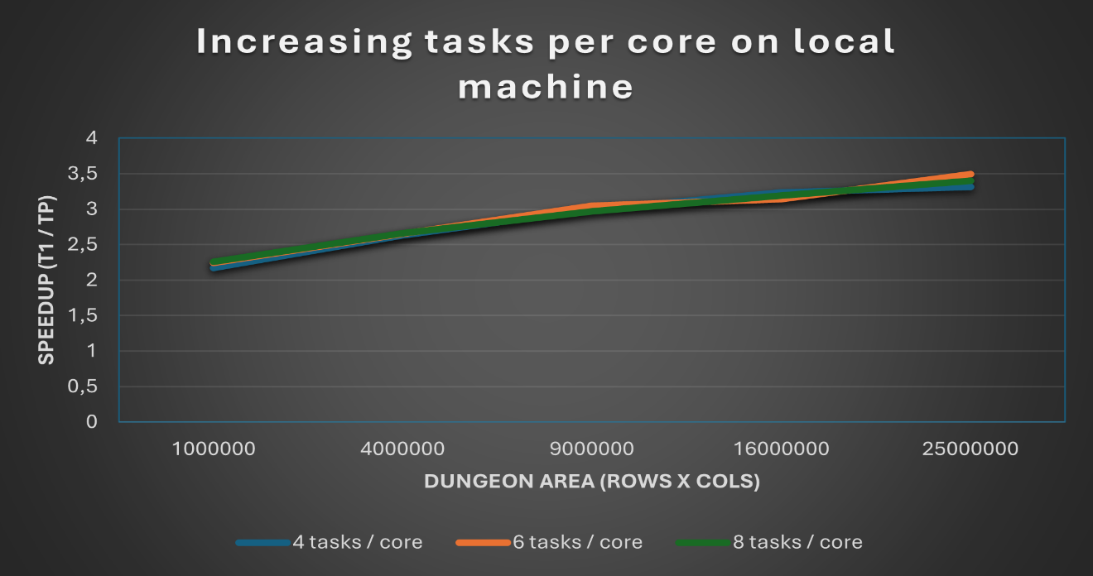

Increasing Dungeon Size on Server
- Fixed the search density to 0.05
- Fixed the seed to 4

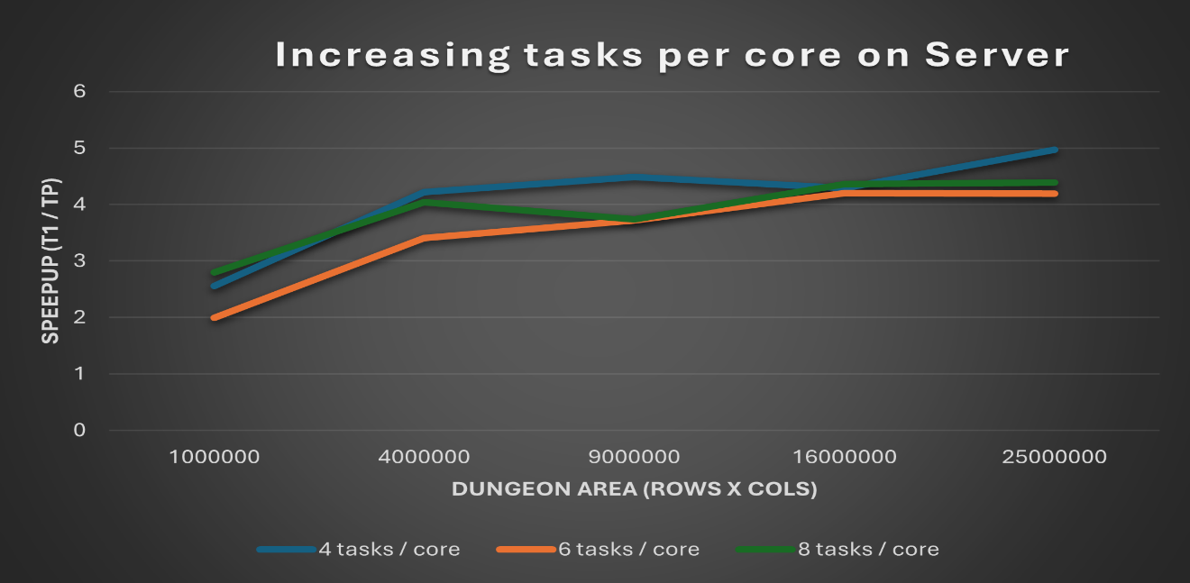

Increasing search density on Local Machine
- Fixed the dungeon size to 200
- Fixed the seed to 4

Increasing Search Density on Server
- Fixed the dungeon size to 200
- Fixed the seed to 4

